

**GROUP ASSIGNMENT**

**TECHNOLOGY PARK MALAYSIA**

**AAPP008-4-2-VBDN**

**VISUAL BASIC .NET**

**UCDF1405ICT(SE)**

**HAND OUT DATE: 7 SEPTEMBER 2015**

**HAND IN DATE: 06 NOVEMBER 2015**

**WEIGHTAGE: 70%**

**INSTRUCTIONS TO CANDIDATES:**

1. **Students are advised to underpin their answers with the use of references (cited using the Harvard Name System of Referencing).**

1. **Late submission will be awarded zero (0) unless Extenuating Circumstances (EC) are upheld.**

1. **Cases of plagiarism will be penalised.**

1. **The assignment should be bound in an appropriate style (comb bound or stapled).**

**Where the assignment should be submitted in both hardcopy and softcopy, the softcopy of the written assignment and source code (where appropriate) should be on a CD in an envelope / CD cover and attached to the hardcopy.**



**VISUAL BASIC .NET**

**AAPP008-4-2-VBDN**

**Group Members:** Khor Zhe Sheng TP035053

Koa Choong Foo TP034743

Lee Guang Zong TP035451

**Intake Code:** UCDF1405ICT (SE)

**Lecturer:** Mr. Kadhar Batcha Nowshath

**Hand out date:** 7th September 2015

**Hand in date:** 6th November 2015

**Contents**

1. Introduction 1

2. Input Screen Design 2

2.1 Login Page 2

2.2 Main Page 3

2.3 Payment 4

2.4 Member report and payment report 5

3. Output Design 6

3.1 Login Page 6

3.2 Main Page 6

3.3 Payment 7

3.4 Member report and payment report 7

4. User manual 8

4.1 Login Page 8

4.2 Main Page 8

4.2.1 Add, remove and edit member’s profile 9

4.2.2 Navigation buttons, search and report 11

4.3 Payment information 13

5. Critical Assessment 14

6. Bibliography 15

1. Introduction

Imperial Golf Club Malaysia has always been one of the most exclusive clubs in Kuala Lumpur. We provide the best experience to each and every one of our customers when they play golf here. The club has an outstanding environment for golfers to enjoy their stay here, the experience can only improve as we progress over the time.

As our golf club members increase, we are required to develop a system to manage and keep track of everyone’s details. The system would enable us to add, remove, update and search for member’s profile. All of the members’ information would be saved inside a database. Each member’s type of membership could also be seen. Their payment entries and transactions will be recorded as well. Reports will be created regularly by the system for reference.

The new system will be capable of handling a large amount of customer’s personal information, providing a simpler experience for the employees to manage our valued customers’ personal info at the end of the day.

2. Input Screen Design

2.1 Login Page

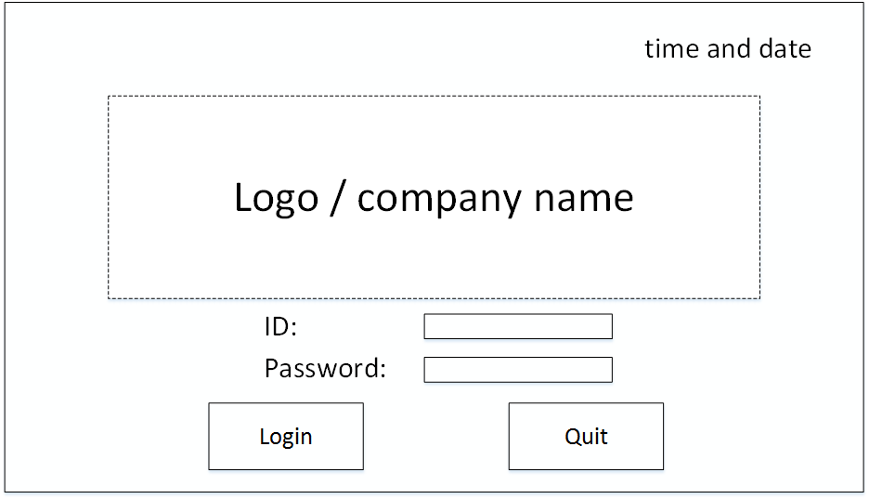

Button 1

Label 1

Label 2

Label 3

Button 2

Textbox 1

Combo box 1

Diagram 2.1

Label 1 - Show time and date

Label 2 - Golf Club Membership Management System user

Label 3 - Golf Club Membership Management System user’s password

Button 1 - Confirm user and password then login to system

Button 2 - Close system

Combo box 1 - Select user

Textbox 1 - Key-in user’s password

2.2 Main Page

Label = 1, 2, 13, 19, 25

Textbox=4, 5, 6, 8, 10, 11

Combo box= 7, 12

Button = 3, 9, 14, 15, 16, 17, 18, 19, 20, 21, 22, 23, 24

25

1

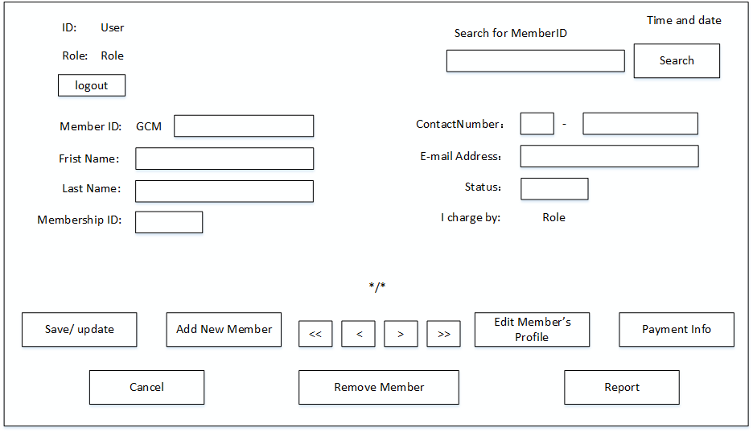

24

23

13

12

11

10

9

25

22

21

20

19

18

17

16

15

14

7

6

5

4

3

2

8

Diagram 2.2

13 - Show User’s name who in charge

14 - Save or update

15 - Cancel

16 - Add member

17 - Show first member’s information

18 - Show pervious member’s information

19 - Show current member / total member

20 - Show next member’s information

21 - Show last member’s information

22 - Edit current member’s detail

23 - Show payment form

24 - Show report form

25 - Show time and date

1 - Show user’s name

2 - Show user’s role

3 - Logout to login page

4 - Member’s ID

5 - Member’s first name

6 - Member’s last name

7 - Membership ID

8 - Key-in member’s ID for search

9 - Press after key-in textbox 8 then search

10 - Member’s contact number

11 - Member’s E-mail address

12 - Member’s status

2.3 Payment

1

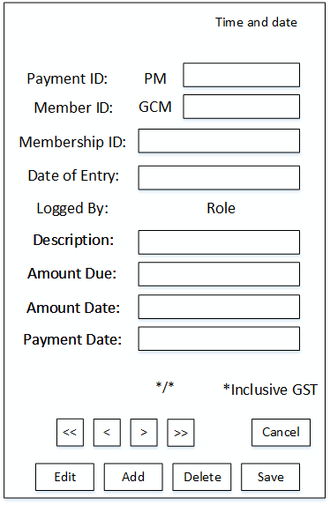

Label = 1, 6, 10, 20

Textbox= 2, 3, 5, 8, 9, 21

Combo box= 4, 7

Button = 11, 12, 13, 14, 15, 16, 17, 18, 19

21

20

19

18

17

16

15

14

13

10

11

12

9

8

7

6

5

4

3

2

Diagram 2.3

11 - Cancel payment

12 - Save or update

13 - Delete current payment record

14 - Add new payment record

15 - Edit current payment record

16 - First payment of that member

17 - First payment of that member

18 - First payment of that member

19 - First payment of that member

20 - Show current member / total member

21 - Show payment date

1 - Show time and date

2 - Show payment ID

3 - Show member’s ID

4 - Show membership ID

5 - Show date of entry

6 - Show user’s role

7 - Show what kind of payment

8 - Show amount due

9 - Show amount paid

10 - Notice payment inclusive GST

2.4 Member report and payment report

Button 1

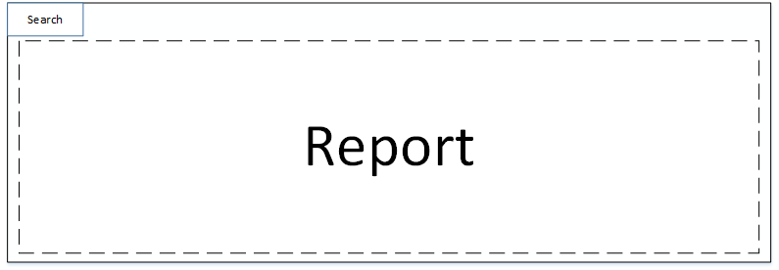

Diagram 2.4

Button 1 - to search which member detail want to show

3. Output Design

3.1 Login Page

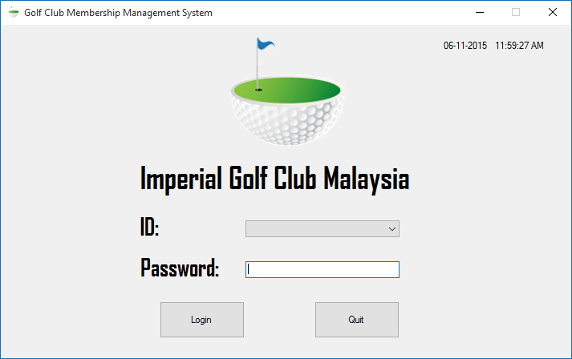

Diagram 3.1

3.2 Main Page

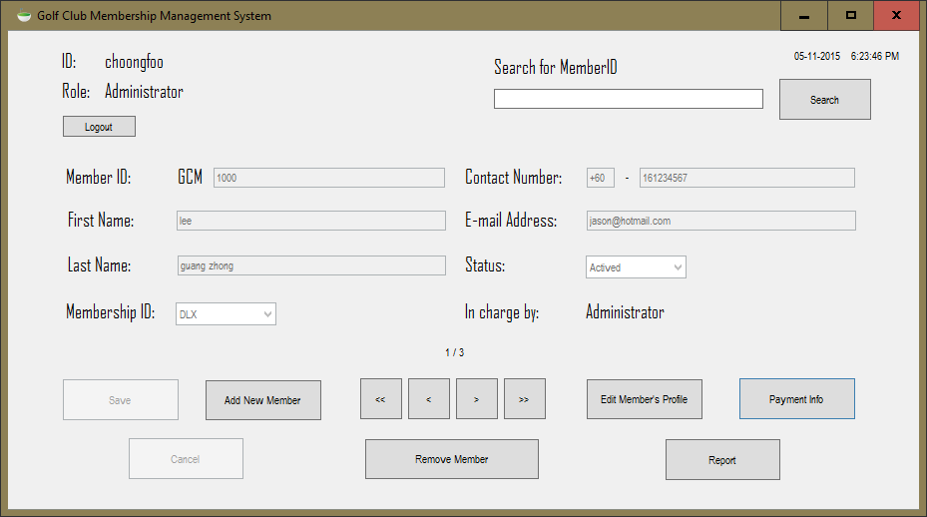

Diagram 3.2

3.3 Payment

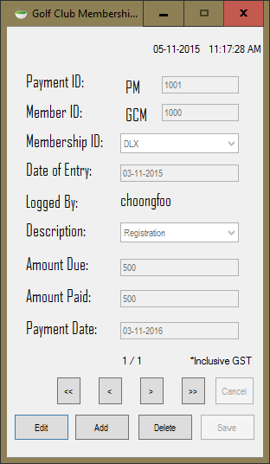

Diagram 3.3

3.4 Member report and payment report

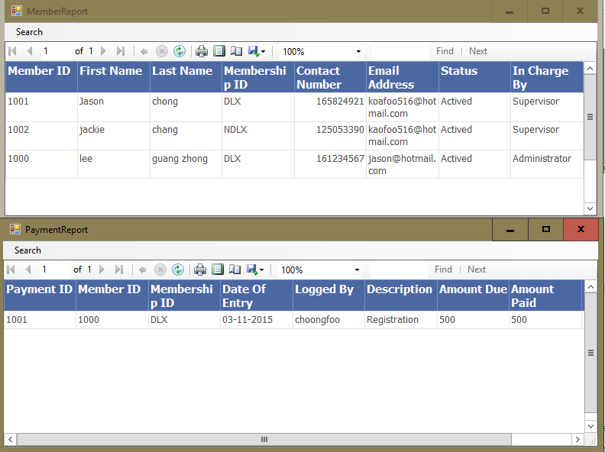

Diagram 3.4

4. User manual

4.1 Login Page



Diagram 4.1

After user’s ID and Password have been entered, press “Login” button to login. The credentials will be verified before the next form is opened. The user will not gain access to the next form if the credentials are incorrectly entered.

4.2 Main Page

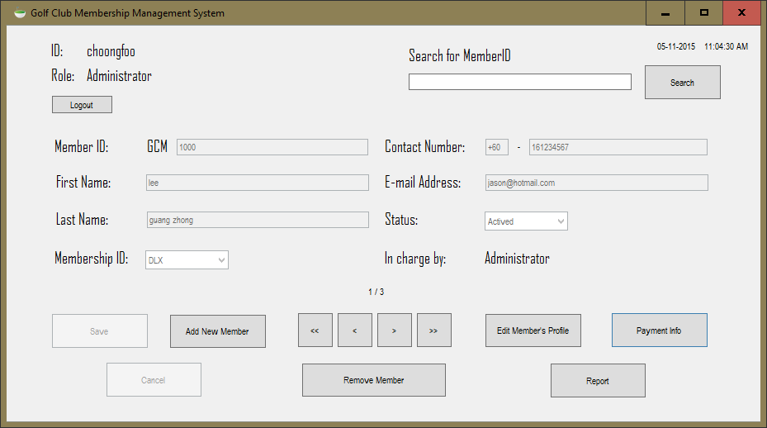

Diagram 4.2

4.2.1 Add, remove and edit member’s profile

1. All the above information will not be modified in any means by default. Press “Add New Member” button in order to add a new member’s profile record into the database. Information entered to create the new profile can only be saved through clicking on the “Save” button. As a result, the message “New member detail is added!” will be shown to inform the user the information has been saved as seen in Diagram (4.2.1). Only click on “Edit Member’s Profile” button to make any changes to the current profile displayed, shown in Diagram (4.2.2). In order to the saved the changes done to the current profile, just click on the “Update” button show in Diagram (**4.2.2**). While editing, the user may wish to cancel it by clicking on the “Cancel” button to undo any changes made.

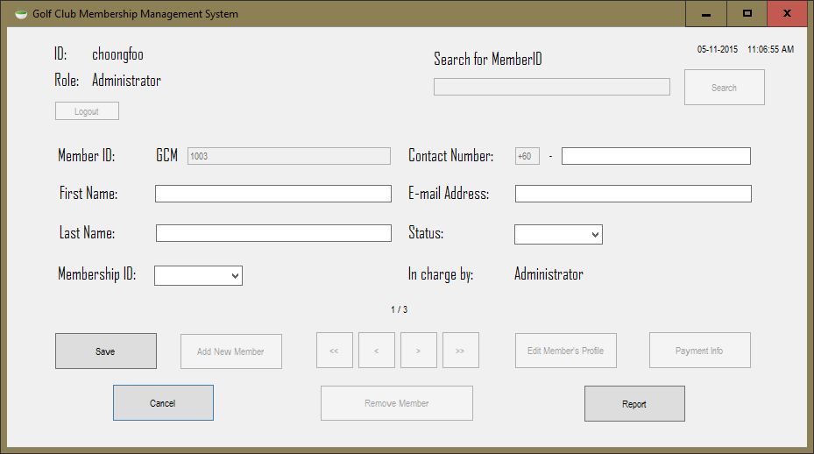

Diagram 4.2.1

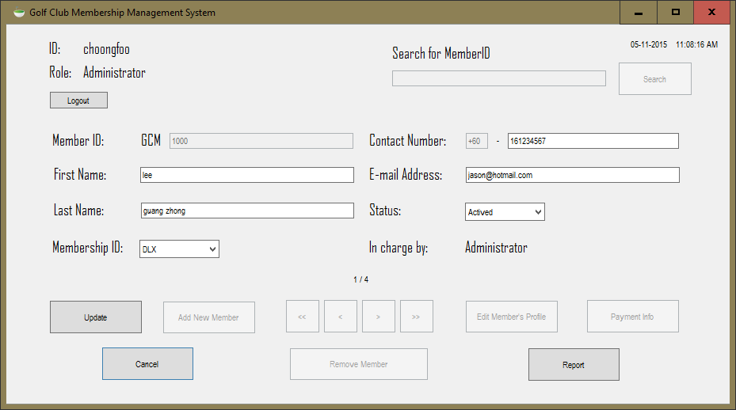

Diagram 4.2.2

2. The user will not be able to create, edit and save any profile if there is any blank information found in the text boxes. The user will be prompted to fill in the boxes correctly with an error message shown in Diagram (4.2.3) before progressing any further.

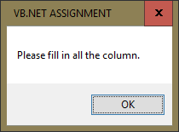

Diagram 4.2.3

1. The user may select and view on any particular member’s record he or she wanted, using the navigation buttons below. Click on “Remove Member" button to remove the member’s profile record from the database. The user will then be asked to confirm if the following deletion is actually wanted, shown in Diagram (4.2.4).

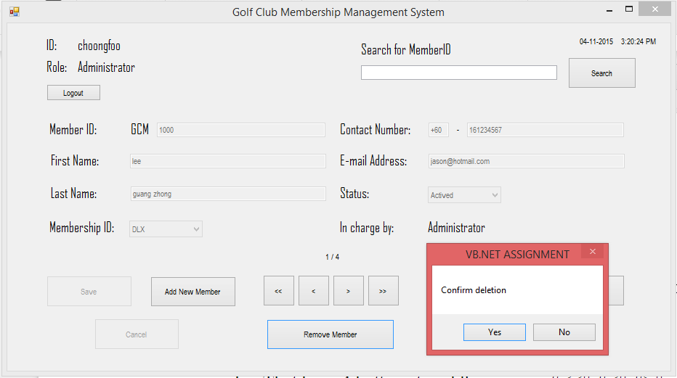

Diagram 4.2.4

4.2.2 Navigation buttons, search and report

1. There are 4 buttons located at the bottom middle section of the form labelled as “<<”, “<”, “>” and “>>”. Clicking on “<<” and “>>” will let the user to skip to the first and last record of the database in the form “<” and “>” are for the user to view or select the next and previous record of the database in the form. Refer to Diagram (4.2.5) below.

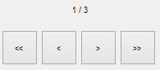

Diagram 4.2.5

1. User may be able to enter any member’s ID number to search for on the top right corner of the form, as seen in Diagram (4.2.6). Just click on the “Search” button by the side.

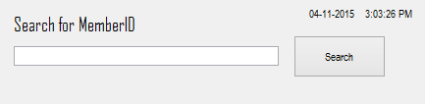

Diagram 4.2.6

1. As an overview, the user may click on “Report” button in the main form to take a look on the list of members and payments report. Example is shown in Diagram (4.2.7).



Diagram 4.2.7

4.3 Payment information

1. If the user wishes to check on the payment information of a member, just click on “Payment Info” button in the main form as seen on Diagram (4.2). The payment info form will then appear as seen in Diagram (4.2.8) below. The payment info shown only belongs to the current member selected on the main form. If the current member has made more than one payment, the payments will each be recorded in the payment info database shown in the form and ready to be browsed through the same set of navigation buttons. Edit, add and delete buttons are also present as well, refer to Diagram (4.2.8) below.



Diagram 4.2.8

5. Critical Assessment

There are a few of strengths and weaknesses found in the new system too. The new system has brought a better security to safeguard customer’s personal information. These information are only available to employees who have been granted access to the system. They must login to the system to view or make any changes to the information. The employees will know where to look for when they need certain information, which means all of the information is properly organised. The user interface is also very well presented. It is easy to understand where certain information should and should not go, every single detail is located at each of their respective locations.

The weaknesses we have found are as follow. There are no ways to recover deleted profiles or information, if they are accidentally removed. These information cannot be access from off-site locations, which may cause inconvenience. They are not synced across the internet, which also means changes can only be made locally. Information authenticity may also be a problem, as there are no means to verify if the information given to us by the customers are actually true.

Here are the solutions that we have prepared to be implemented in the future to address the aforementioned weaknesses. We would add the ability to let users undo deletion of records to avoid accidental removal and recover records or information immediately. We would then setup a server later on to provide cloud syncing to enable off-site access to the application and database. The last solution would require customers to provide their I/C number in the future, in order to let us verify if they are who they claimed to be. The database would be updated to let employees add customers’ I/C number later on.

6. Bibliography

1. Stack Overflow (2013) VBA Check if button has been clicked. [Online] Available from: <http://stackoverflow.com/questions/17883988/vba-check-if-button-has-been-clicked> [Accessed: 5th of November, 2015]
2. ConnectionString.com (2014) Access connection strings. [Online]   
   Available from: <https://www.connectionstrings.com/access/> [Accessed: 5th of November, 2015]
3. Microsoft Developer Network (2015) OleDbConnection Class. [Online] Available from: <https://msdn.microsoft.com/en-us/library/system.data.oledb.oledbconnection%28v=vs.110%29.aspx?f=255&MSPPError=-2147217396> [Accessed: 5th of November, 2015]
4. Microsoft Support (2015) How to use the OleDbDataAdapter to fill a DataSet object from an ADO Recordset object in Visual Basic .NET.  [Online]  
   Available from: <https://support.microsoft.com/en-us/kb/310349> [Accessed: 5th of November, 2015]